NIST Cybersecurity Framework

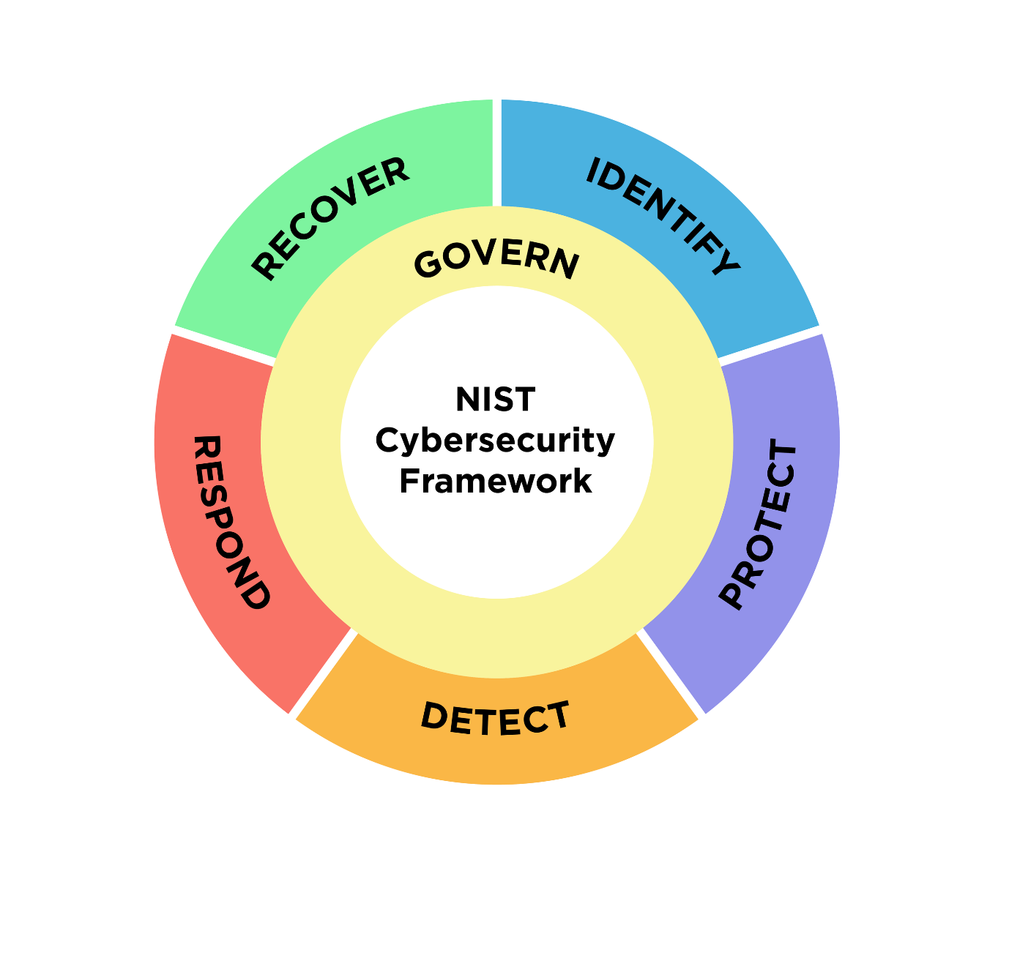

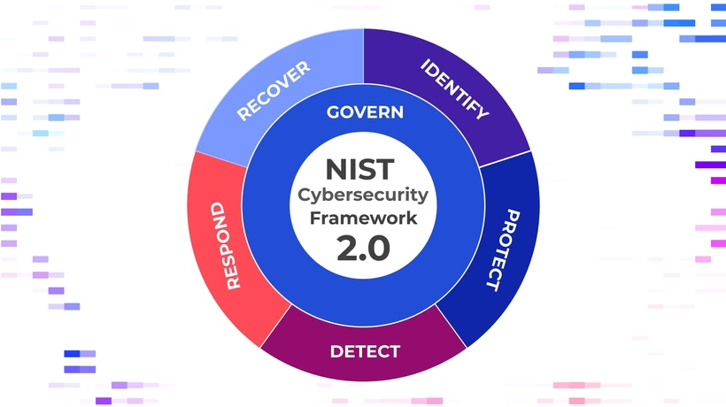

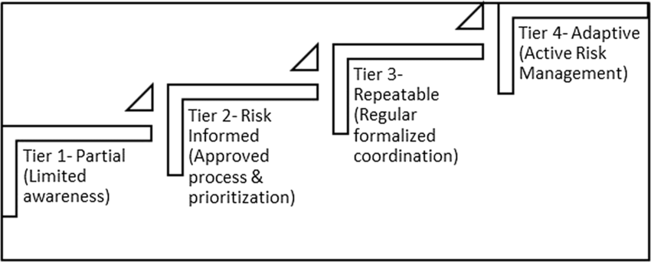
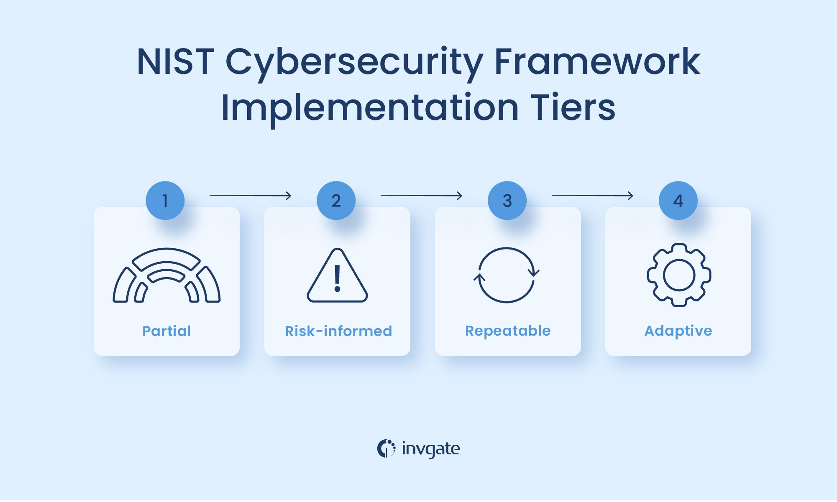
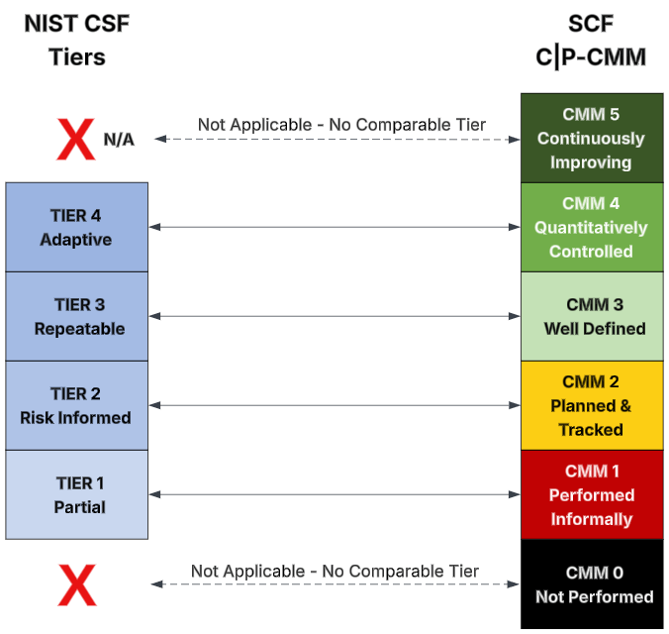

The NIST Cybersecurity Framework (CSF) is a voluntary risk management framework developed by the National Institute of Standards and Technology to help organizations manage and reduce cybersecurity risks. First released in 2014 and updated as Version 2.0 in 2024, it provides a globally recognized structure for identifying, protecting, detecting, responding to, and recovering from cyber threats (NIST).
Key facts
- Developer: National Institute of Standards and Technology (NIST)
- Latest version: 2.0 (Feb 26 2024)
- Core functions: Govern, Identify, Protect, Detect, Respond, Recover
- Intended users: Organizations of any size or sector
- Nature: Voluntary, outcome-based framework
Structure and functions
CSF 2.0 organizes cybersecurity activities into six concurrent core functions.
- Govern – establishes governance, strategy, and roles for cybersecurity risk.
- Identify – inventories assets and assesses risk context.
- Protect – implements safeguards such as access control and data security.
- Detect – monitors systems to recognize anomalies and events.
- Respond – contains and mitigates incidents through structured plans.
- Recover – restores capabilities and improves resilience post-incident (Cyberhaven).
Profiles and implementation tiers
Organizations tailor the framework through Profiles, comparing a “Current Profile” to a “Target Profile” to prioritize improvements. Implementation Tiers (Partial, Risk-Informed, Repeatable, Adaptive) describe the maturity of risk management practices, enabling continuous assessment rather than formal certification (Cyberhaven).
Global use and alignment
The CSF’s flexible and outcome-focused design has led to broad international adoption across industries—from critical infrastructure to small businesses. It maps to other standards such as ISO/IEC 27001, CIS Critical Security Controls, and NIST SP 800-53, providing a common language for communicating cyber risk within and across organizations (Cyberhaven).
Notability and impact
The NIST CSF has become the de facto standard for cyber risk management worldwide. Its expansion in Version 2.0—especially the new Govern function and explicit inclusion of all organizational types—reflects a shift from technical controls to enterprise-wide cybersecurity governance and resilience. By emphasizing communication between technical and executive stakeholders, the CSF continues to shape modern cyber risk strategy (NIST).

